Project Report Template

1.INTRODUCTION

* 1. Overview

The bank will issue you a visa fee receipt in duplicate which will have a 10 digit barcode number affixed on it. You require this barcode number to schedule your visa interview appointment. It takes two days for the barcode to get activated.

* 1. Purpose

It allows the bearer to visit the issuing country for tourism purposes. A tourist visa does not permit the passenger to legally work or carry out business in the specified country or territory. A type of visa is required for these purposes.

2.Problem Definition & Design Thinking

2.1 Empathy Map

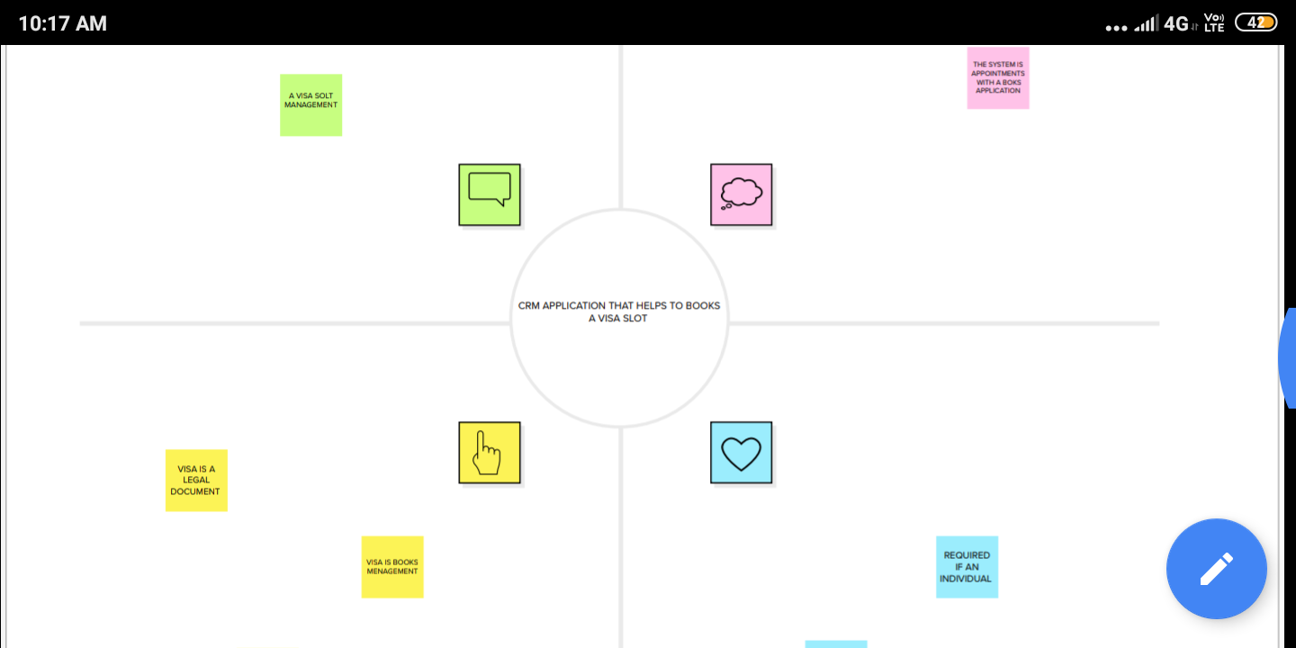

* 1. Ideation & Brainstroming Map

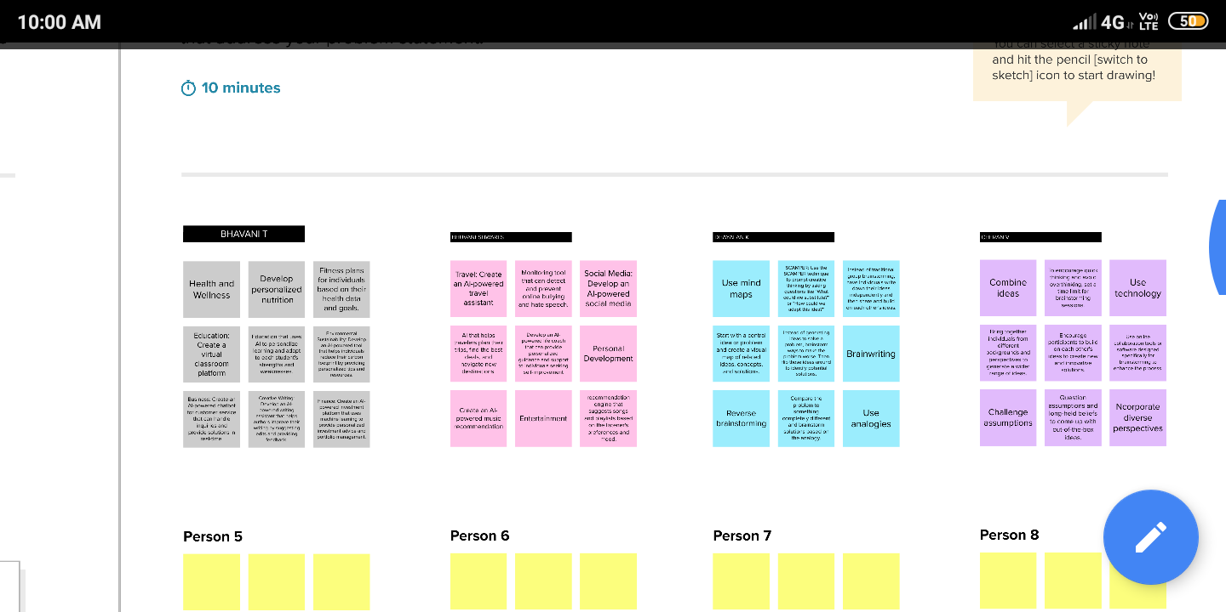

3 RESULT

3.1 Data Model:

Object name. Fields in the object

Obj1. Field label. Data type

Passport passport number

Visa slot passport number

Obj2. Field label. Data type

Payment passport number

Reschedule passport number

3.2 Activity & Screenshort

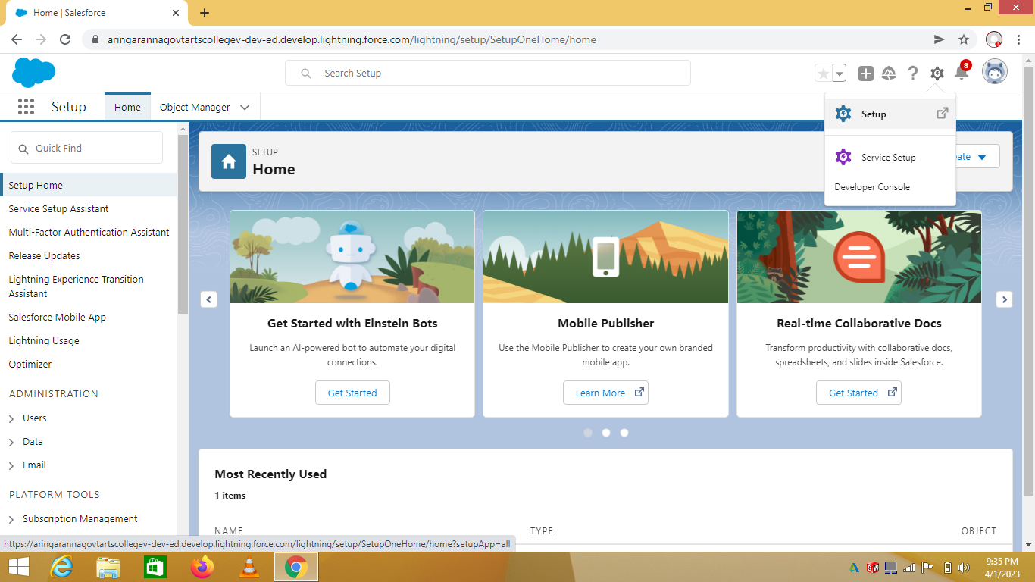

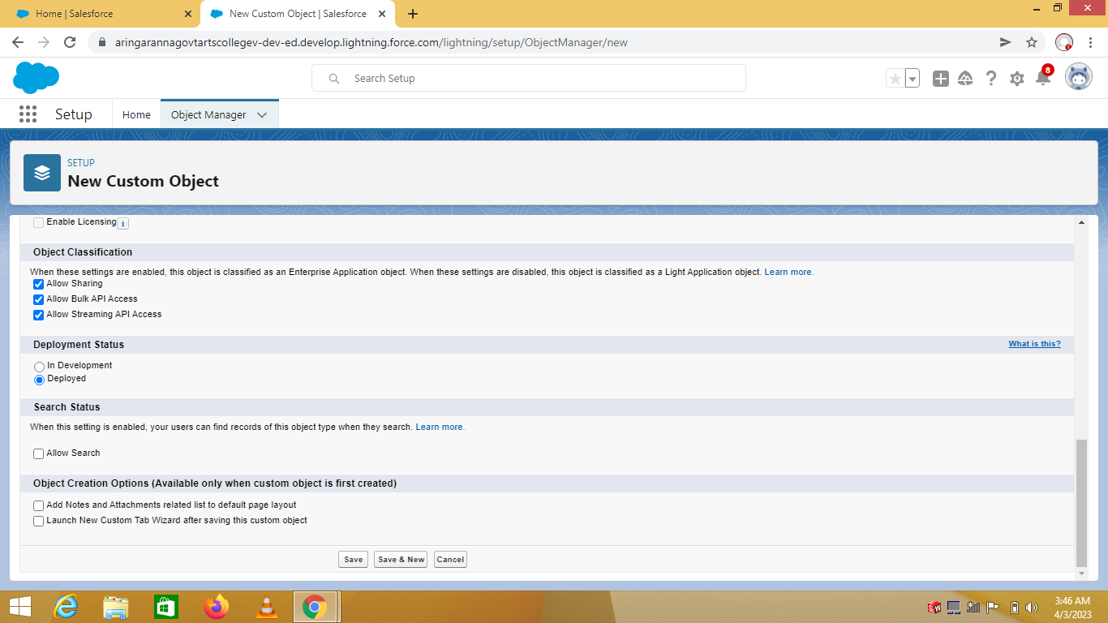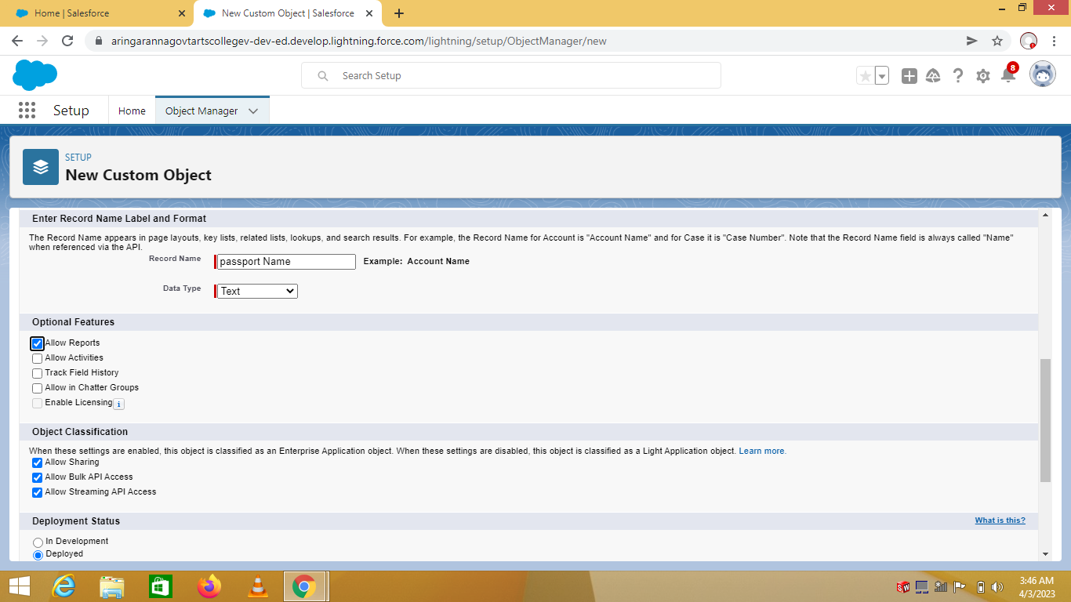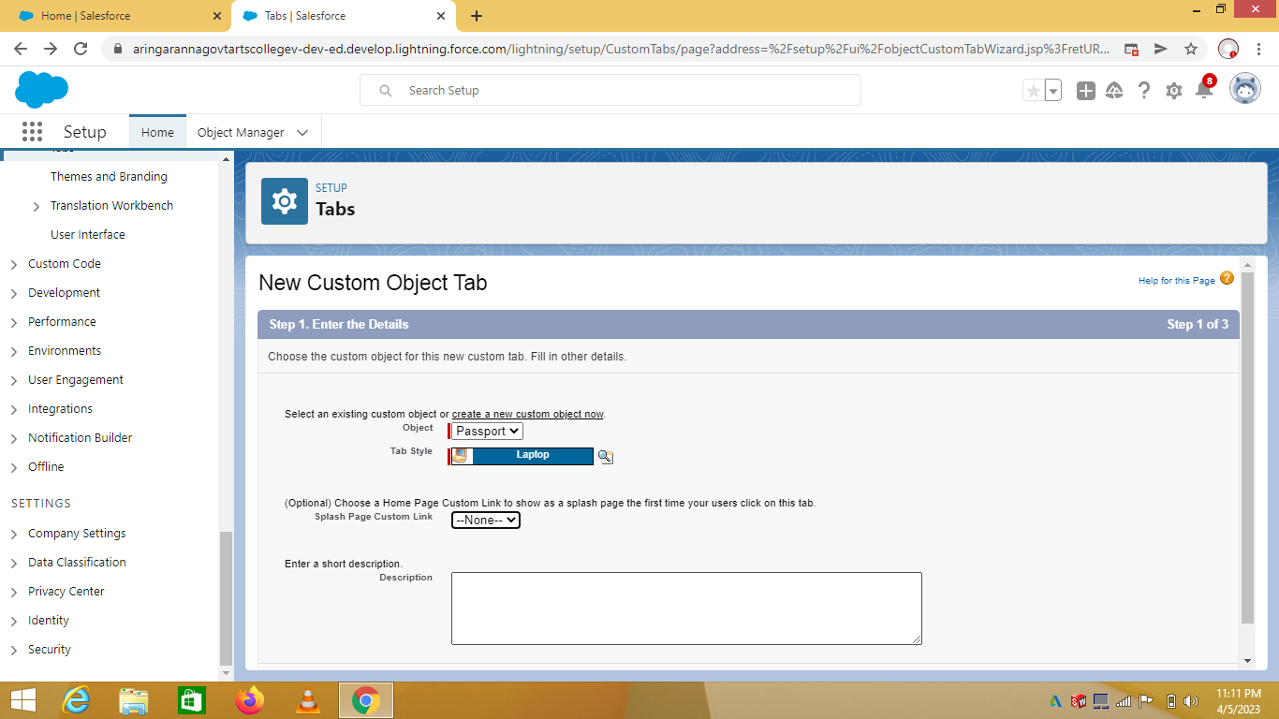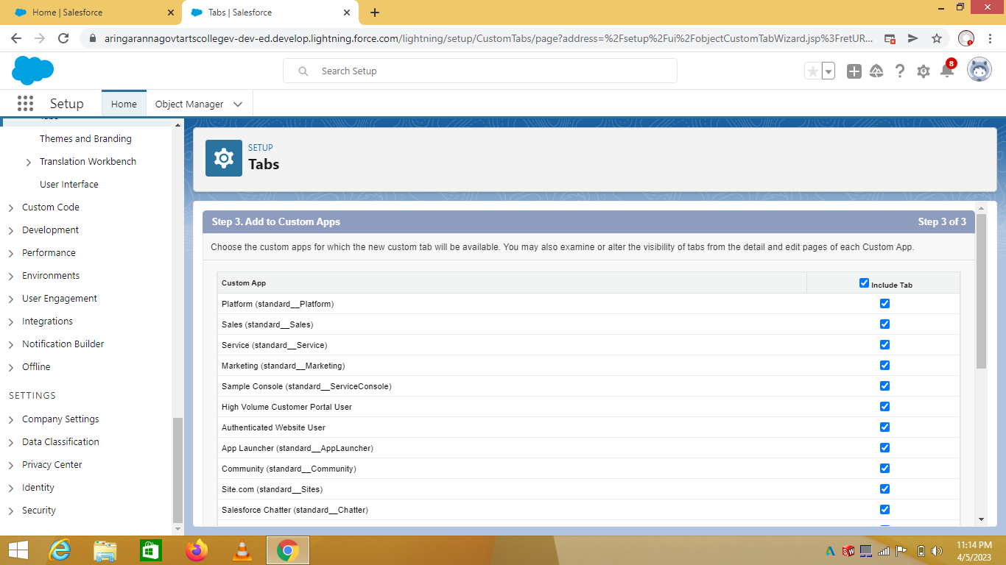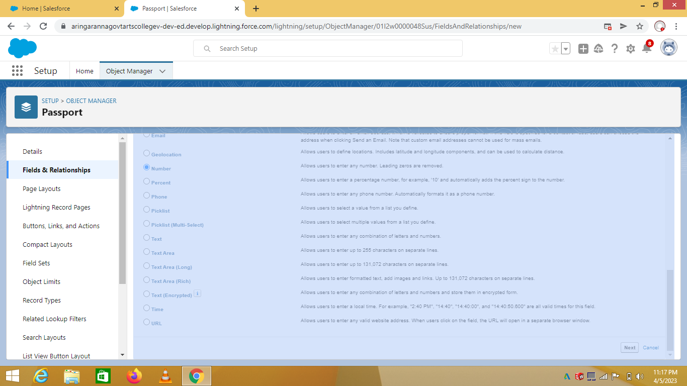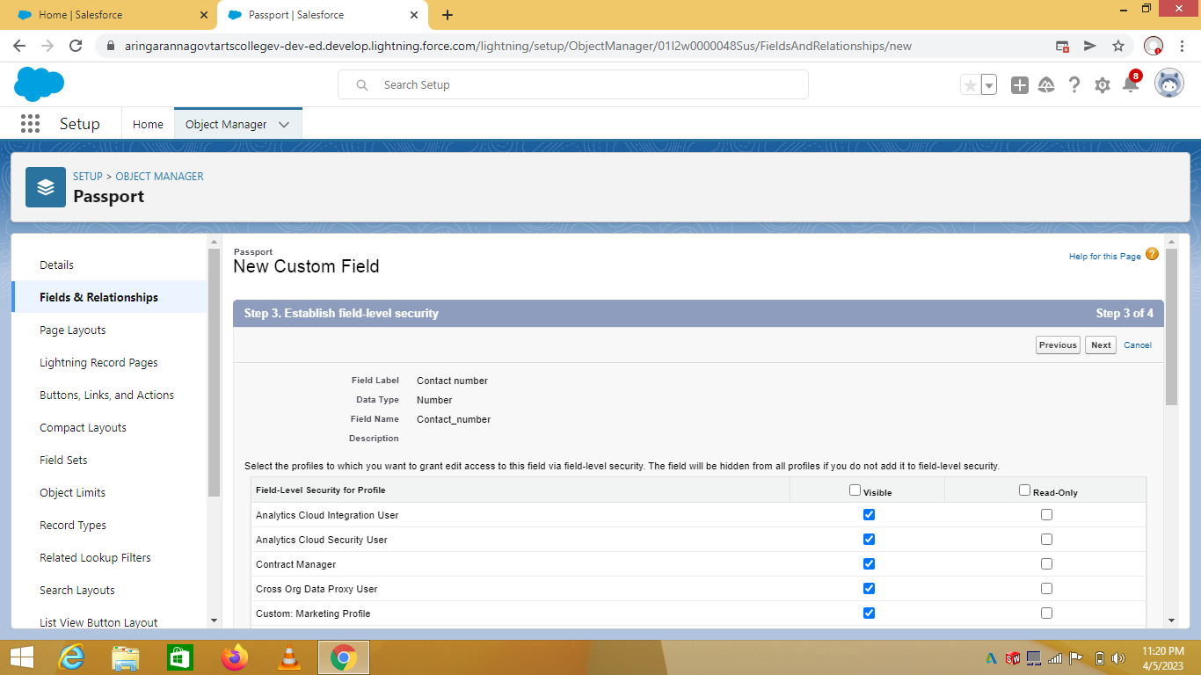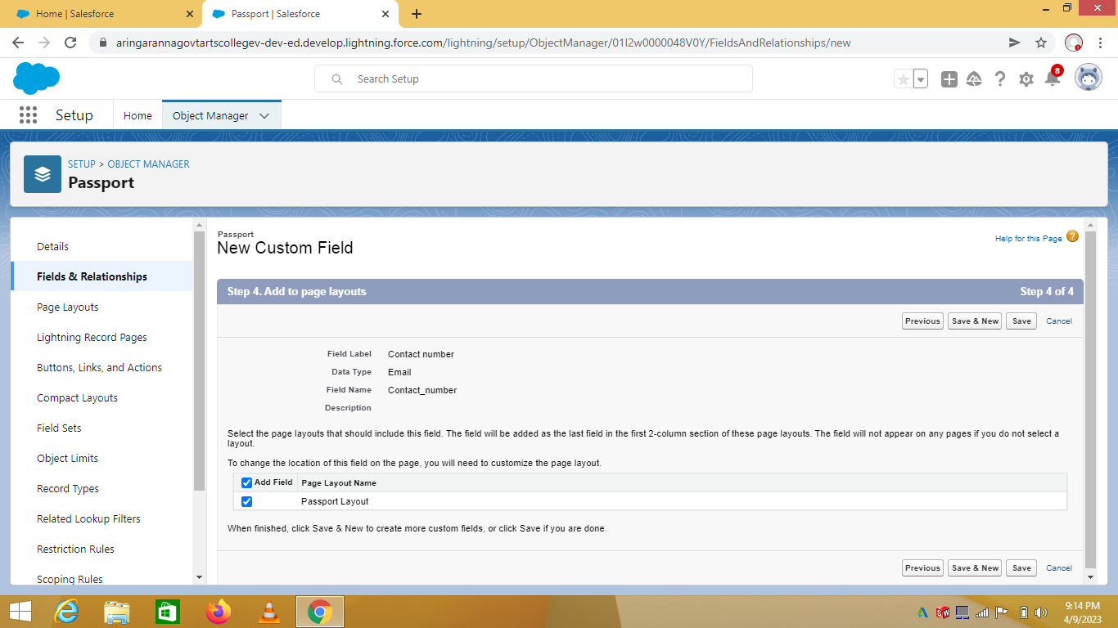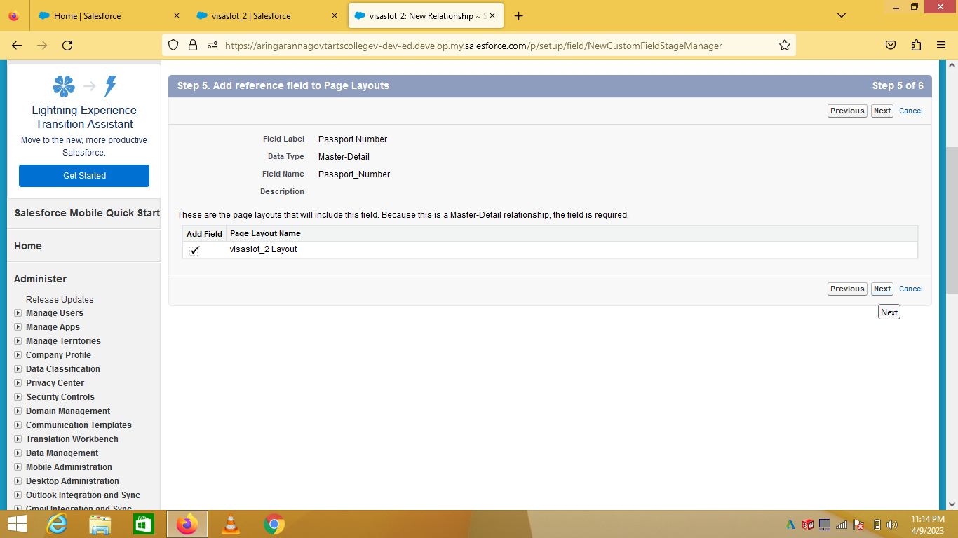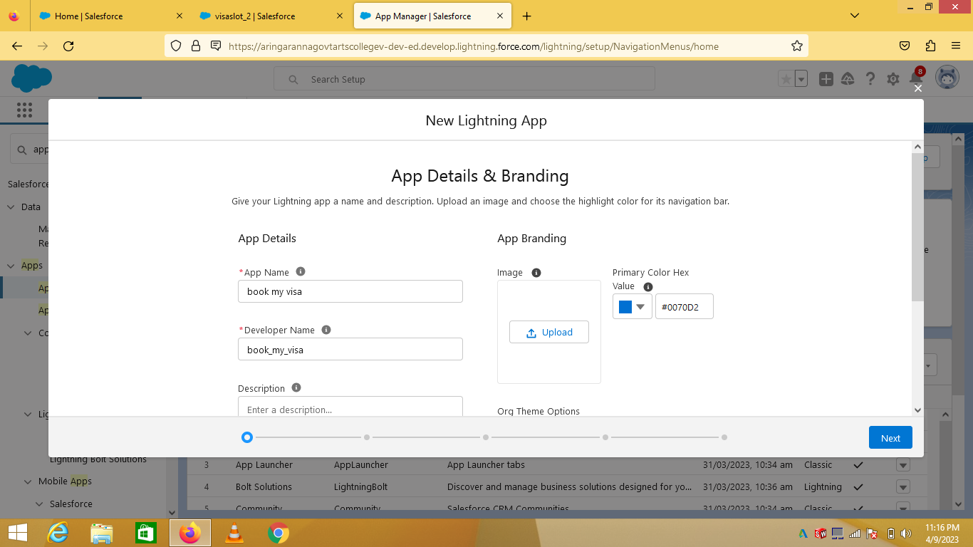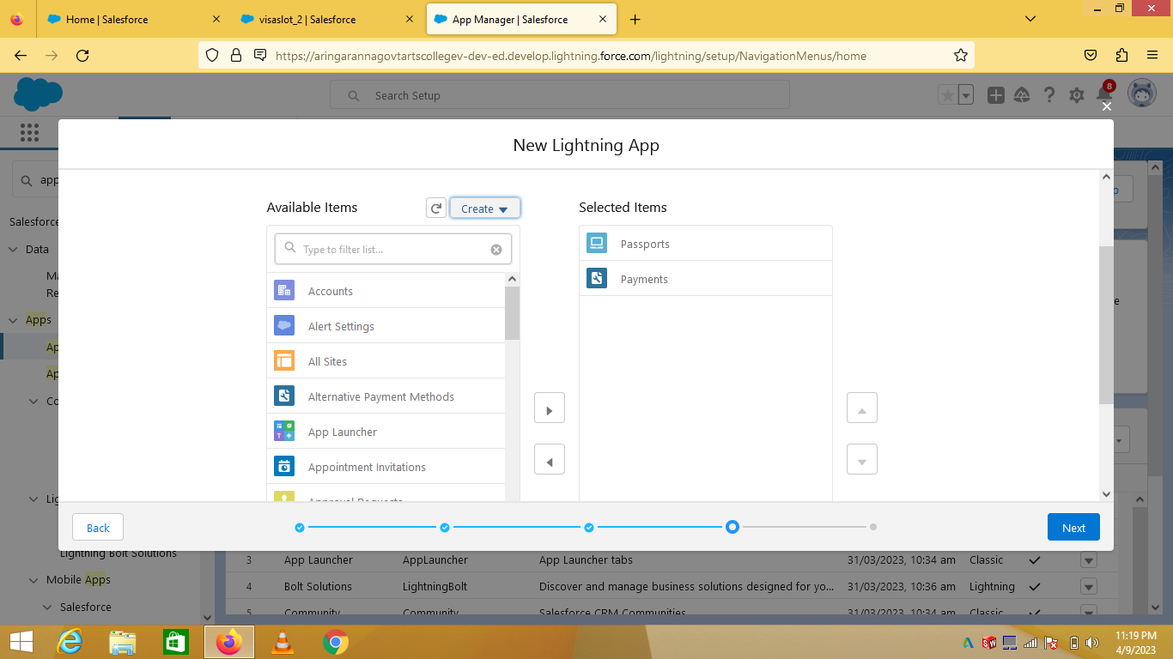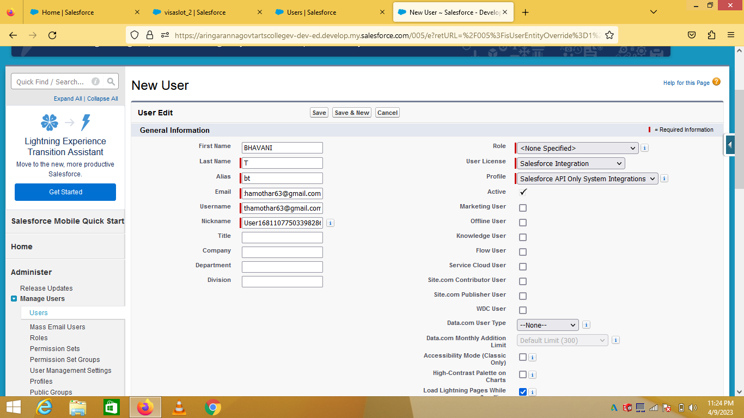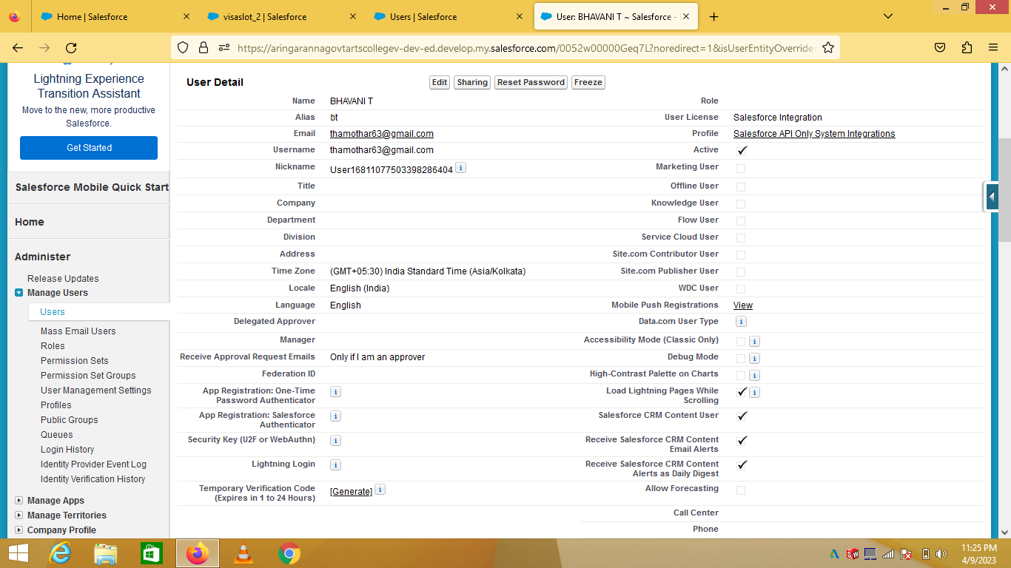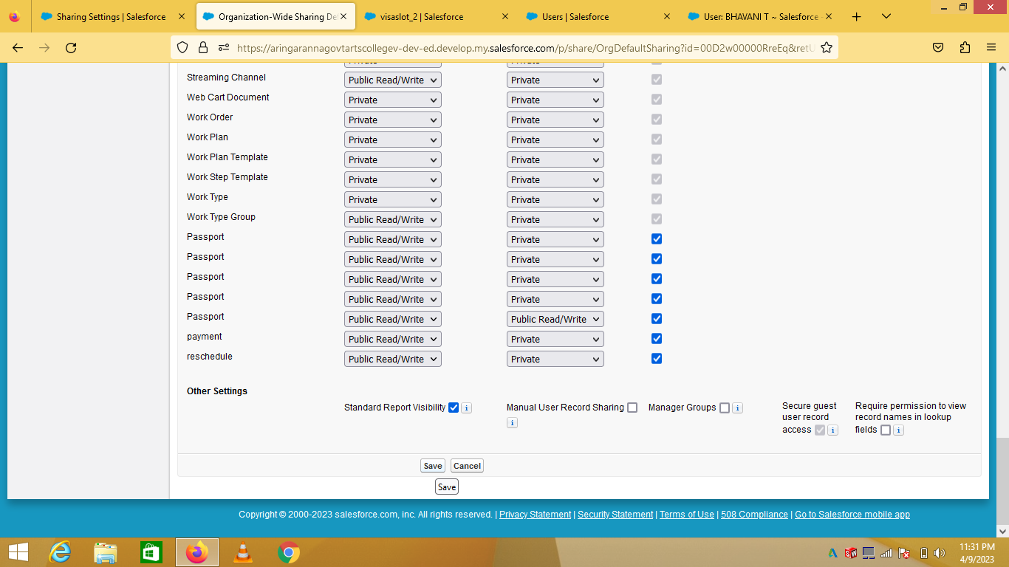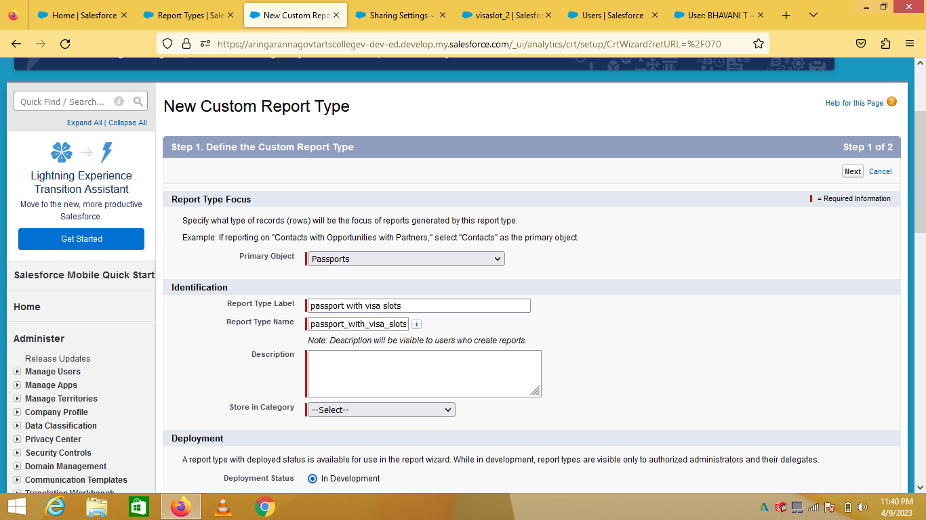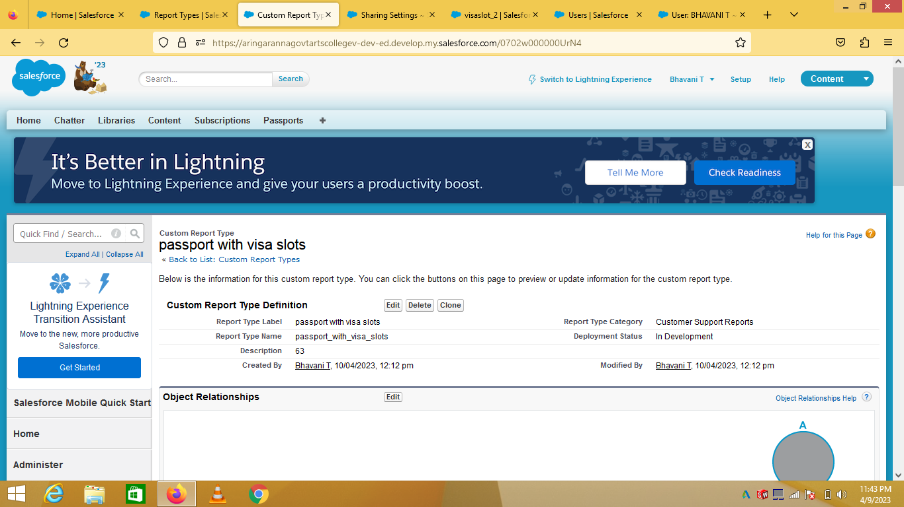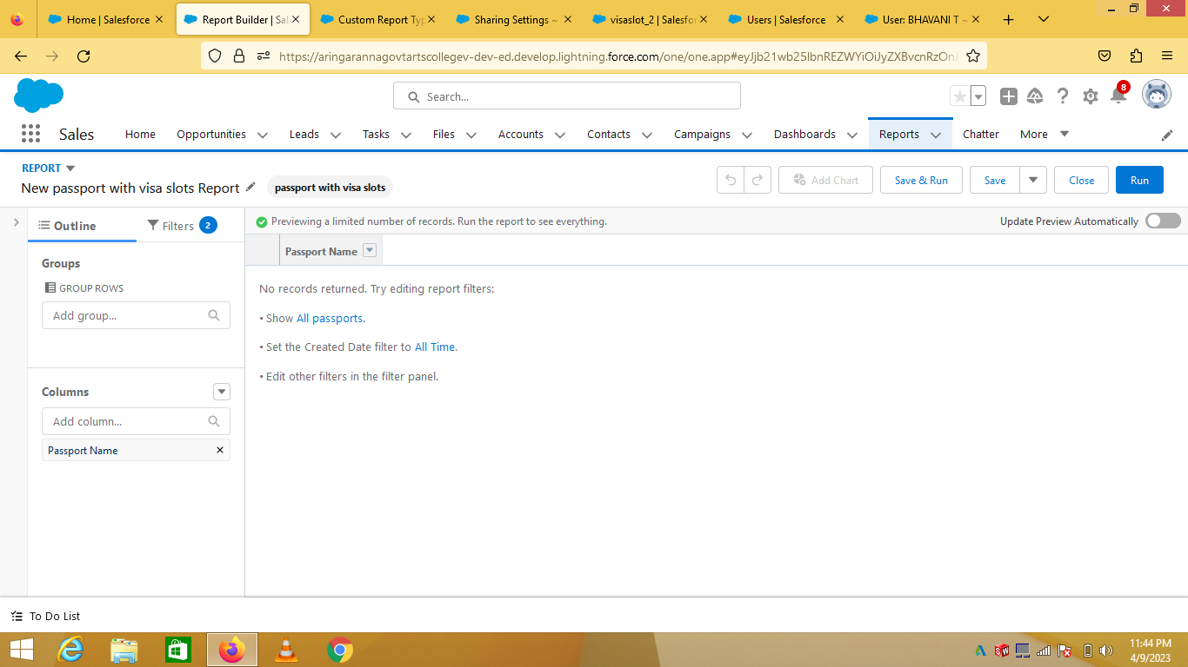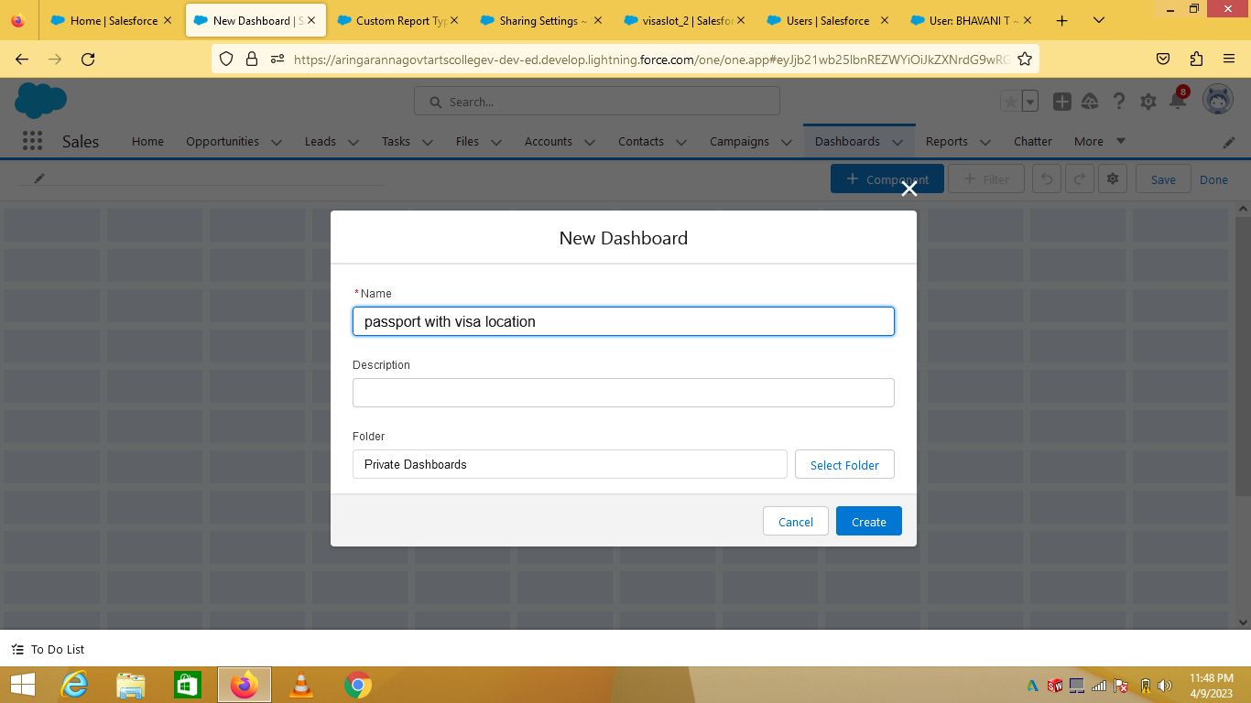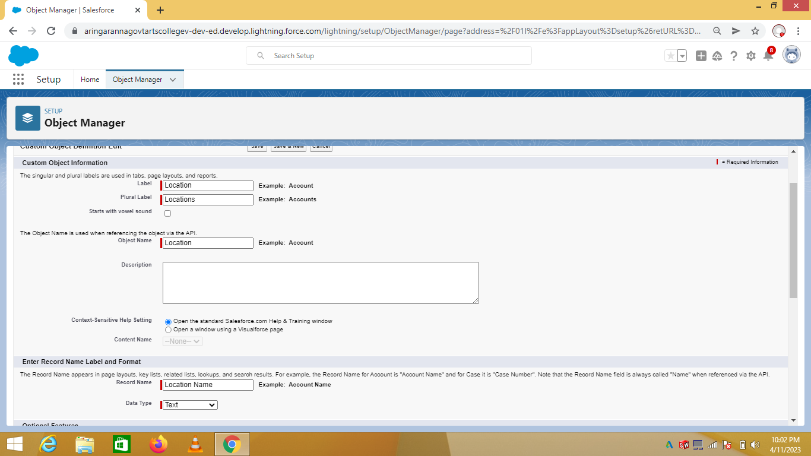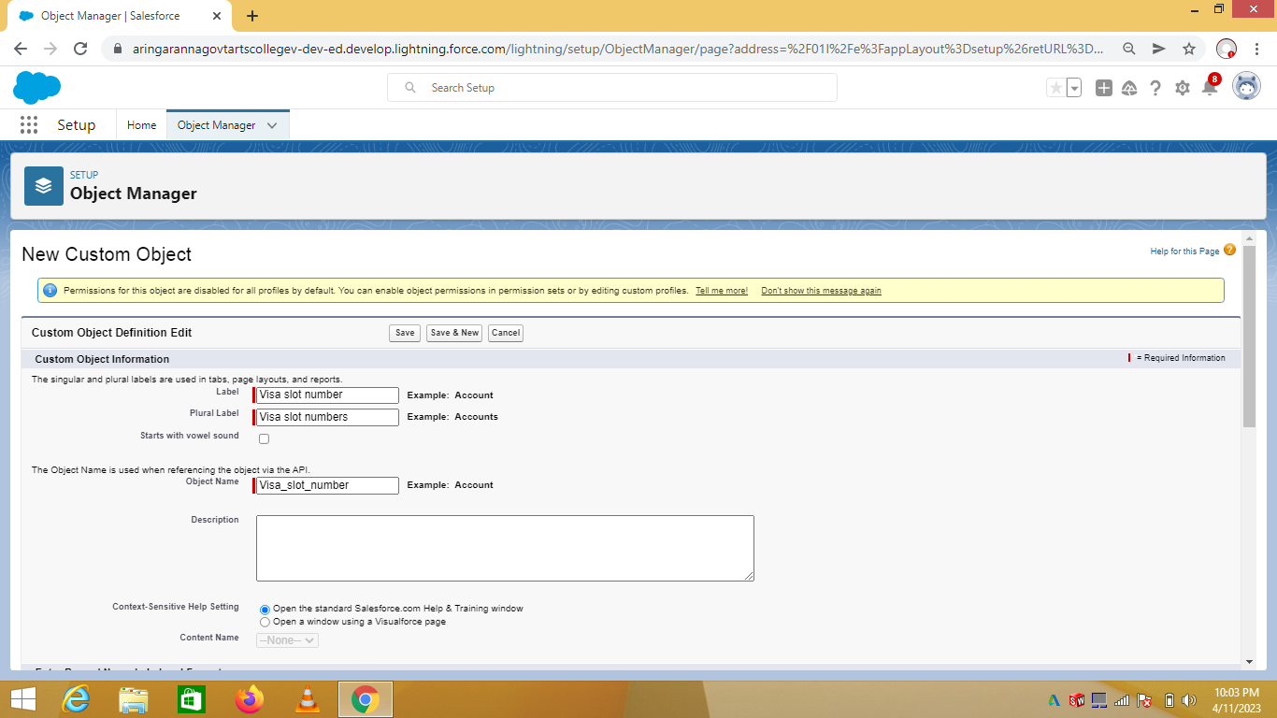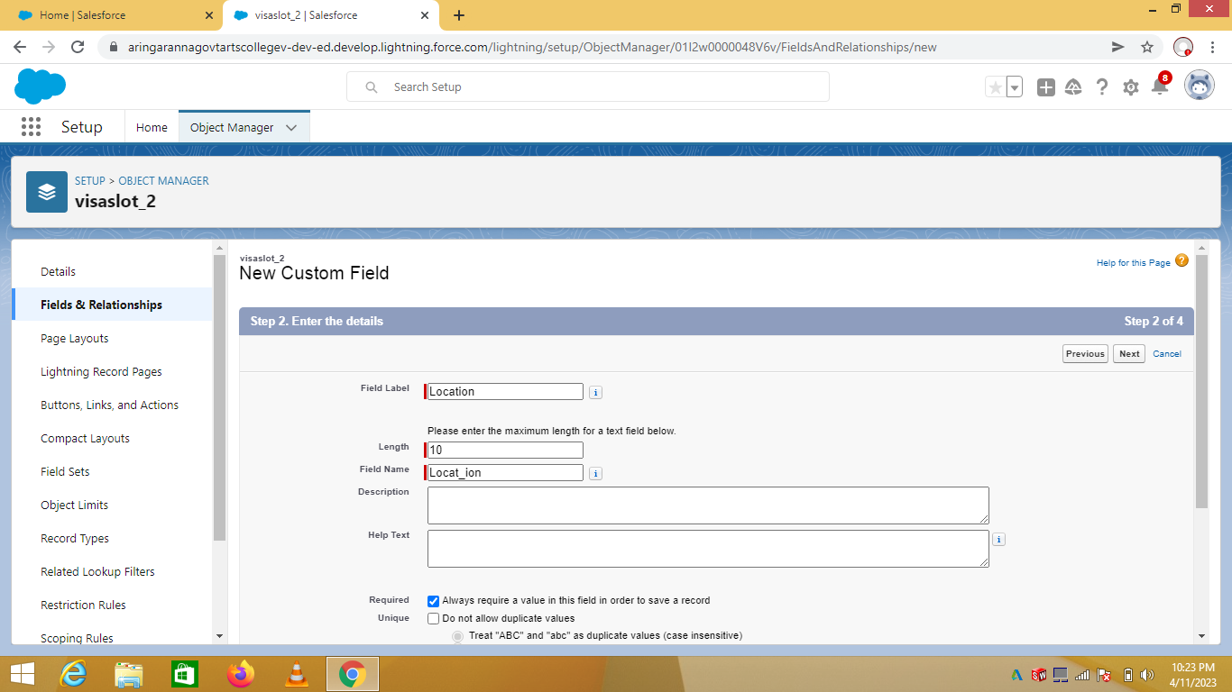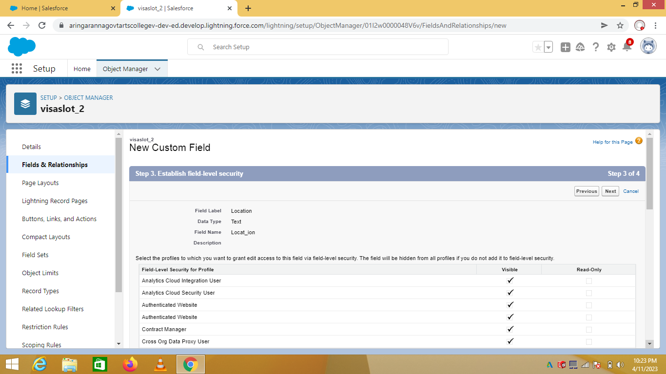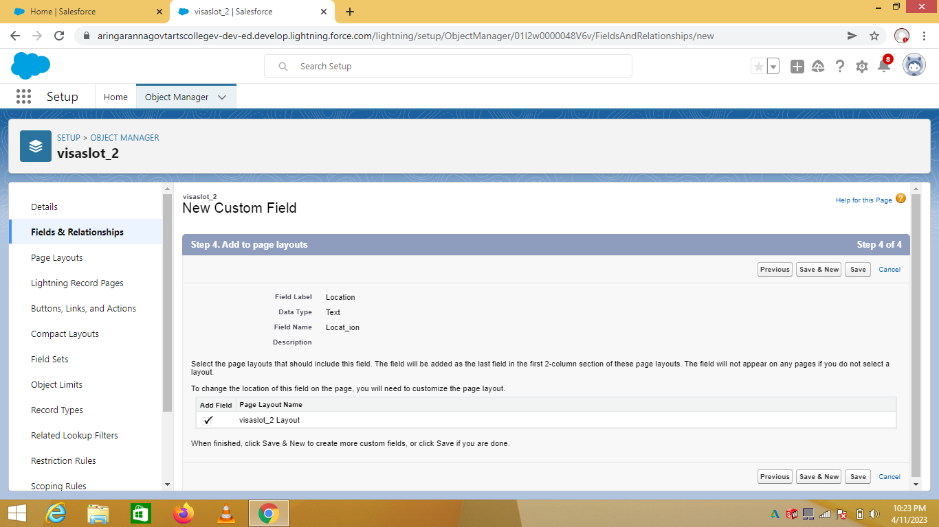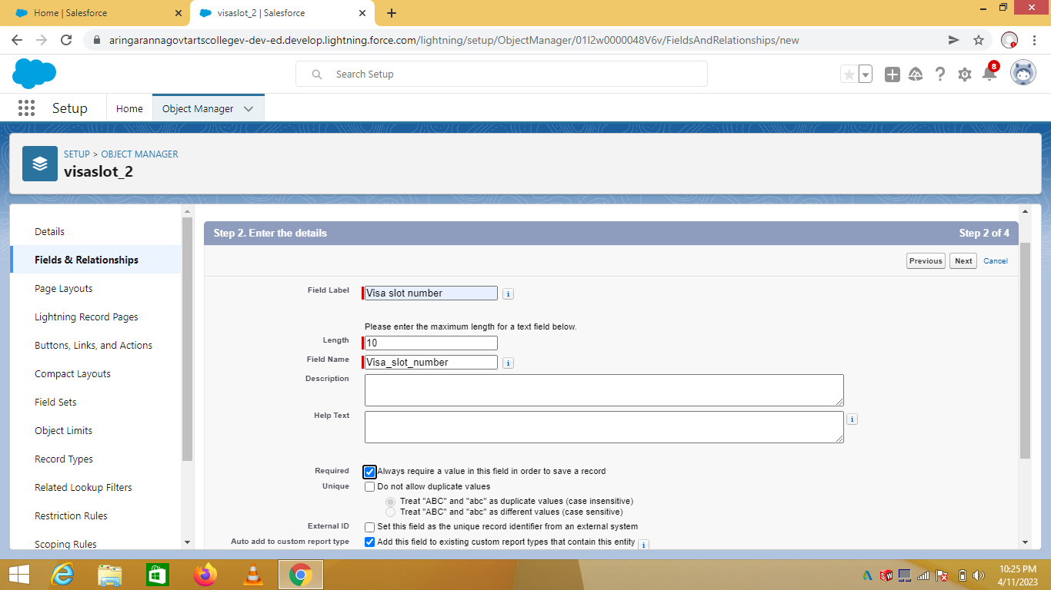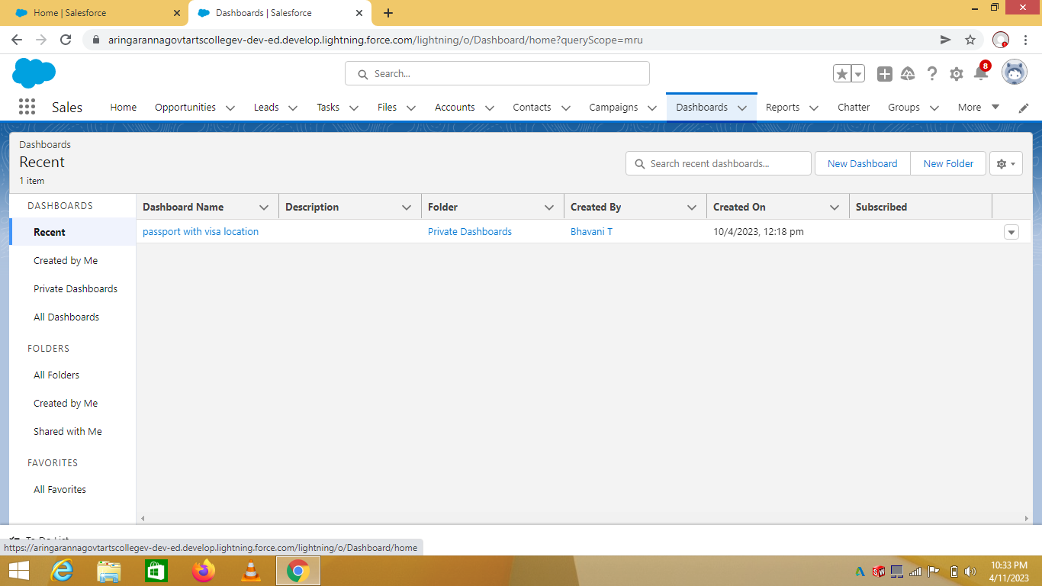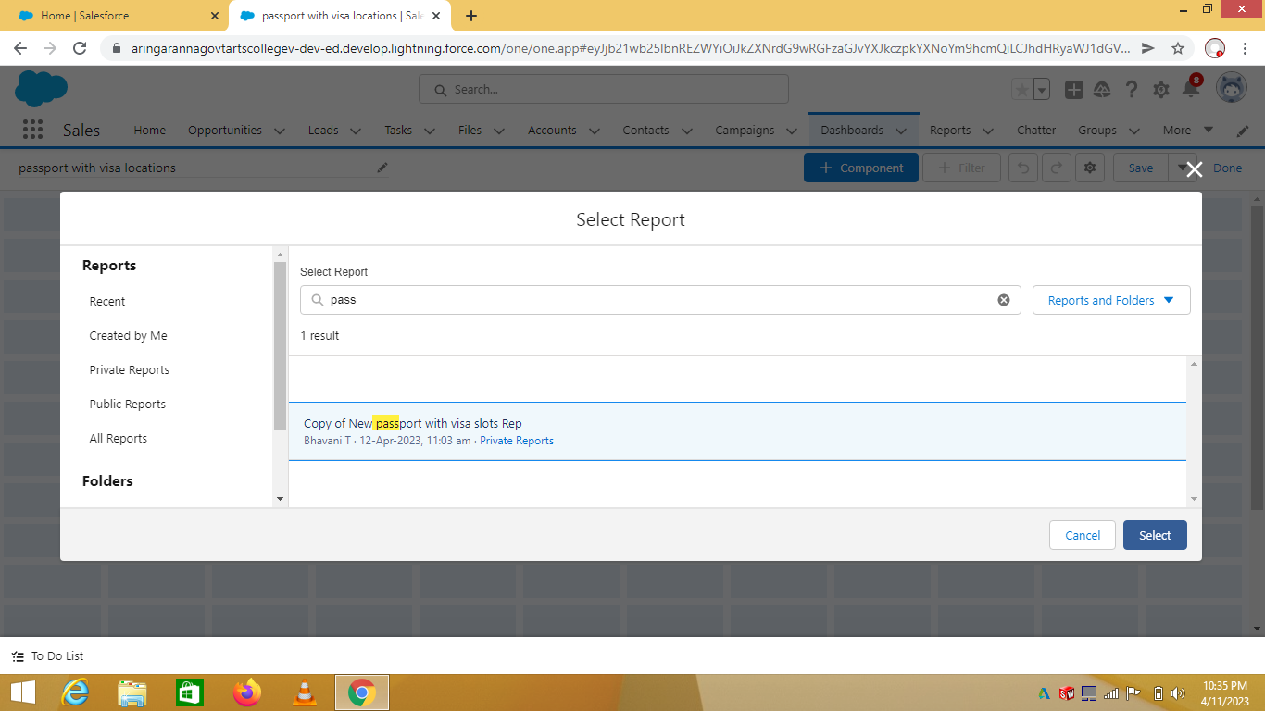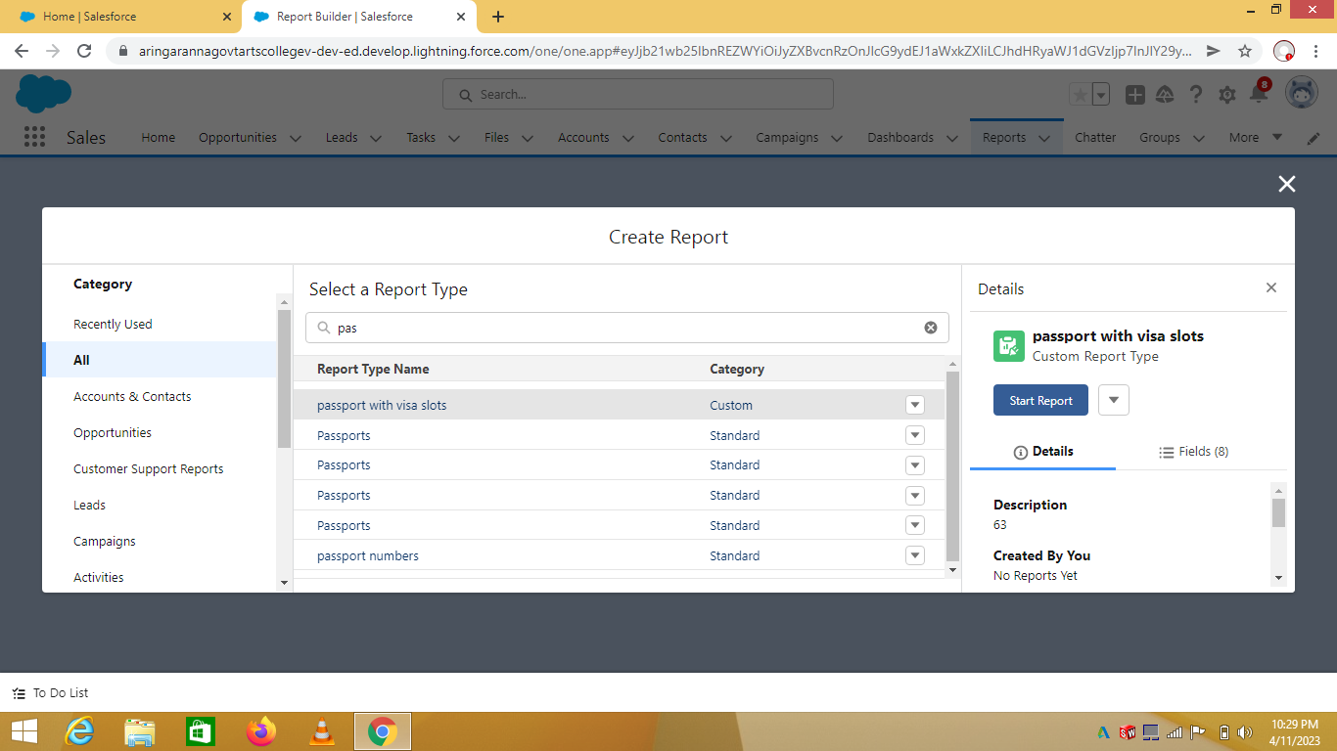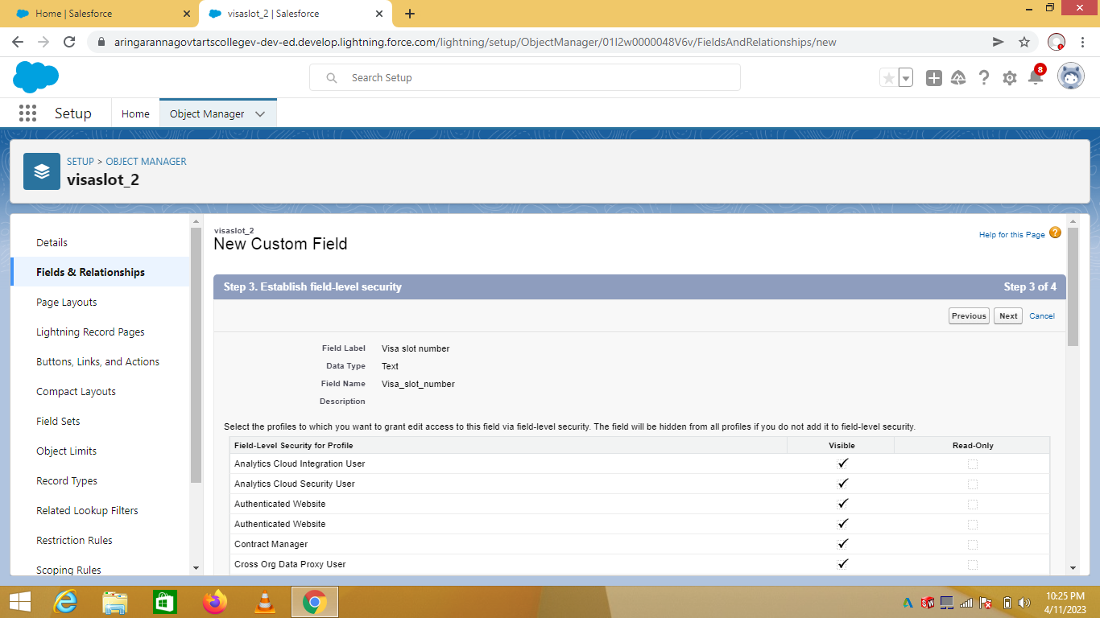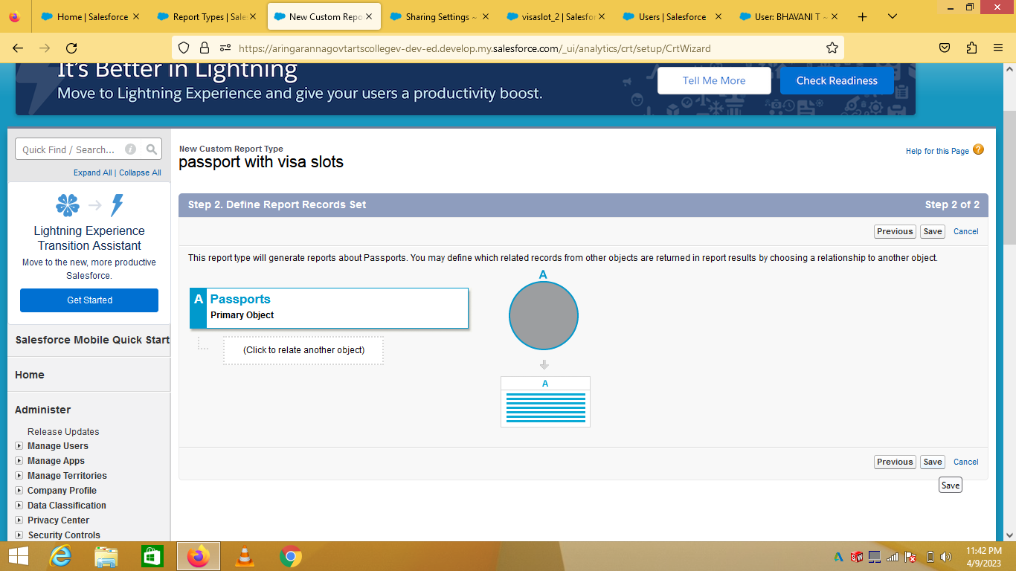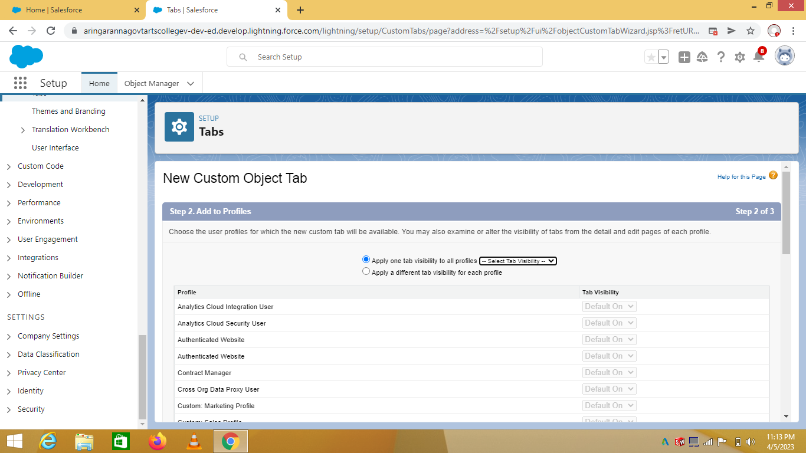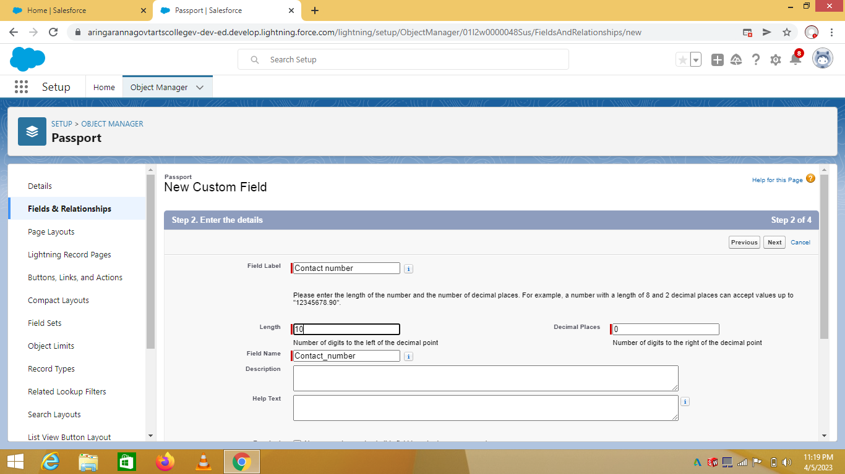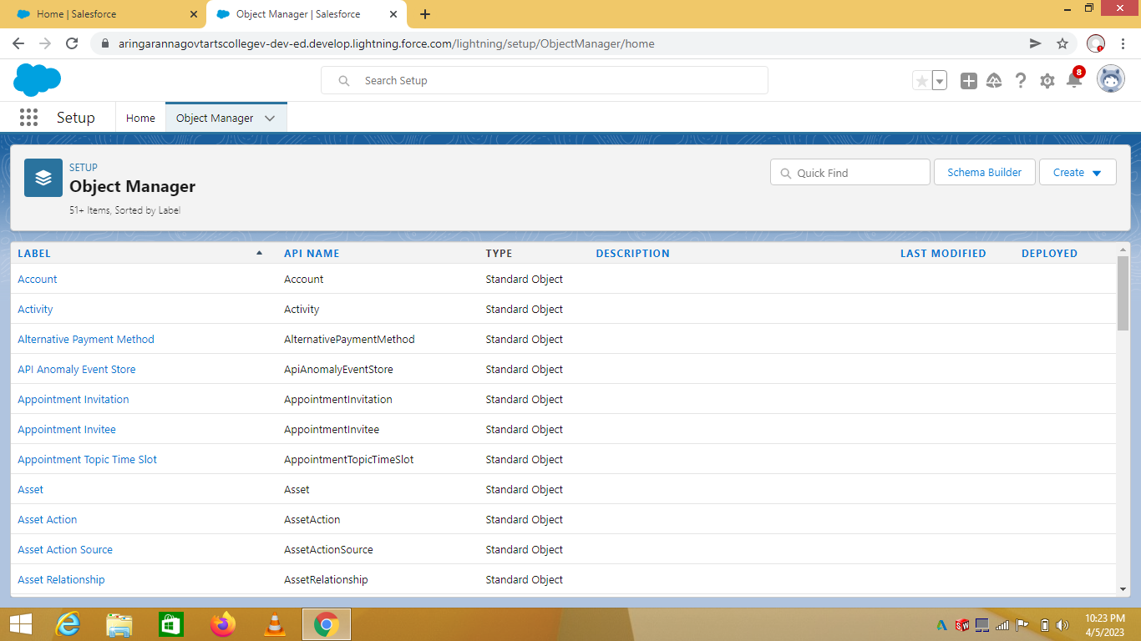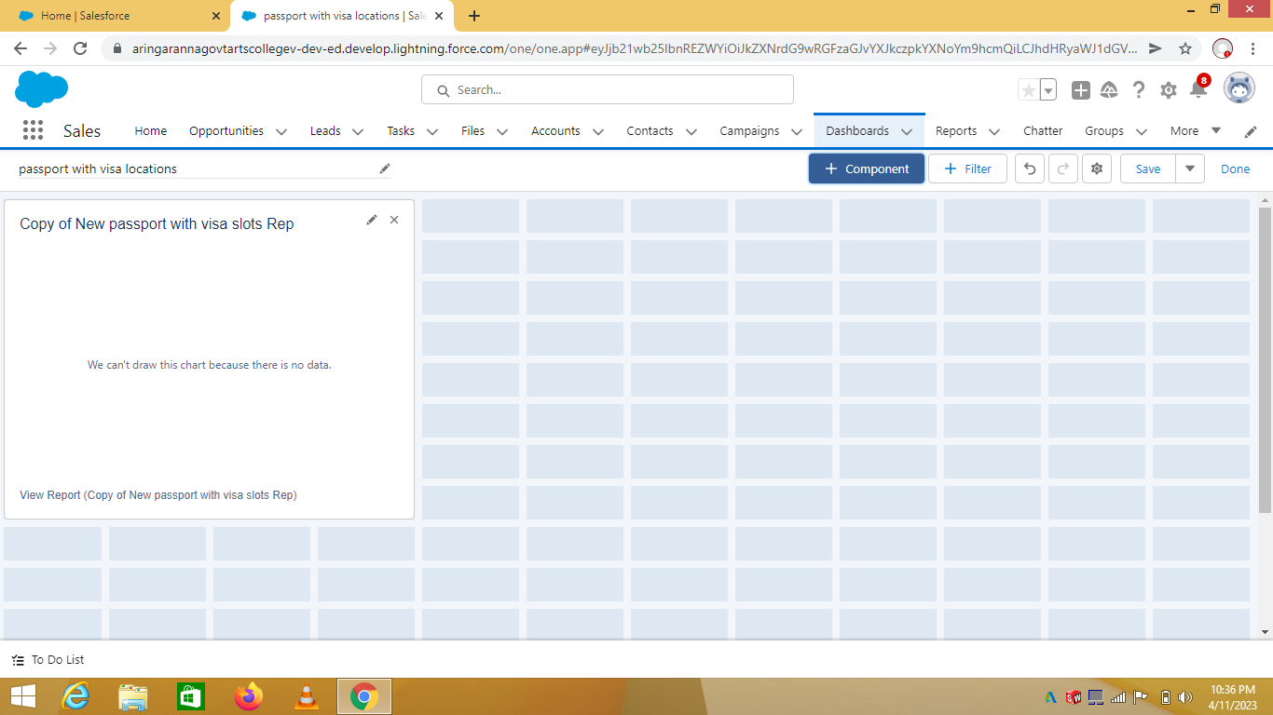

1. Trailhead profile public URL

Team lead BHAVANI.T <https://trailblazer.me/id/bhavt13>

Team member 1.BHUVANESHWARI.S <https://trailblazer.me/id/bhuvs25>

Team member 2. CHERAN.V <https://trailblazer.me/id/cheran1512>

1. ADVANTAGES &DISADVANTAGE

ADVANTAGES

When the application is approved, the visa is sent to the email and can be downloanded.

One of the major benefits of e _Visa is that you don’t have to wait at the airport after arrival in the country.

This will save you from the paperwork,the hassle of queues and documentation.

Disadvantage

The ture of the matter is that on paper,you might meet every qualification,but if you don’t have the right answers for you interviewer and be able to say them with substance and sincerity,you will not aucceed.

6 APPLICATIONS

The United States Department of State has announced a much _needed update for international students looking to study in the US.

Starting from March 1st,2023,prospective F_1 student visa applicants can now apply up to 365 days before their academic term begins.

1. CONCLUSION

Customer Relationship Management enables a company to align its strategy with the needs of the customer in order to best meet those needs and thus ensure long-term customer loyalty.

1. FUTURE SCOPE

CRM systems might imply automation, but many only offer baseline automation options. The future of CRM will include users who demand more functionality. They’ll be looking for providers that cover typical CRM essential as well as more sophisticated automation.

